**Topic: Recurrence Relation and Compound Interest**

Time: 45 mins Marks: /45 marks

**Calculator Assumed**



**Question One: [3, 8: 11 marks]**

a) Compare the amount of interest earned in one year on a $20 000 investment which is earning 8.8% interest p.a if interest is compounding:

i) annually

ii) monthly

iii) daily

b) Write the recursive rule to determine the value of the investment at the end of each year for each of the different compounding periods mentioned in part a).

**Question Two: [2, 4, 3, 2, 2: 13 marks]**

Kerry is saving a deposit to buy a house. She has some money which she invests in an account paying 9.0% interest p.a compounding monthly. She adds $500 to this account at the end of each month.

|  |  |  |  |  |
| --- | --- | --- | --- | --- |
| Month  (n) | Balance at the start of the month ($)  (Tn) | Interest ($) | Installment ($) | Balance at the end of the month ($) |
| 1 | A | 37.5 | 500 | B |
|  |  |  |  |  |
| 3 | 6079.03 | 45.59 | 500 | 6624.62 |
| 4 | C | D | 500 | E |

Kerry was trying to calculate her future savings but she spilled coffee on the table and some of the information became smudged.

a) Calculate A, the value of the initial investment.

b) Calculate the value of B, C D and E.

c) Write the recursive rule to describe the amount of money in the account at the start of each month.

d) What is the balance in the account at the end of the first year?

e) If Kerry wants to have a $20 000 deposit in 18 months’ time, how much do her monthly installments need to be?

**Question Three: [8 marks]**

Consider the following investment accounts for a $10 000 investment over 10 years.

A: 7.2% interest p.a compounding annually for the first 3 years and then monthly at a rate of 6% p.a there after.

B: 5.0% interest p.a compounding monthly.

C: 4.5% interest p.a compounding daily.

Which account offers the highest return?

**Question Four: [3 marks]**

The following graphs relate to the recursive rules below. Match each graph to the relevant recursive rule.

1. 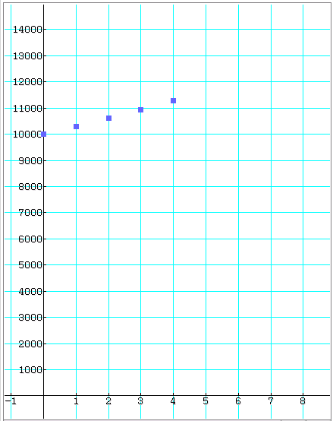 2. 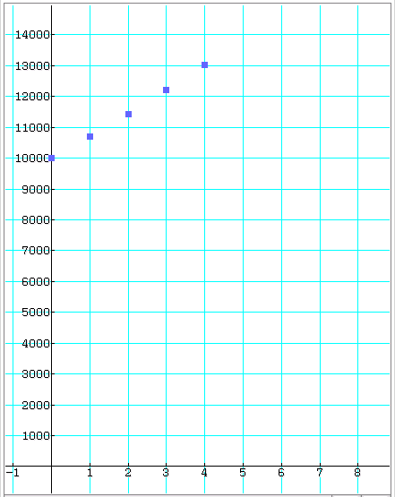

3. 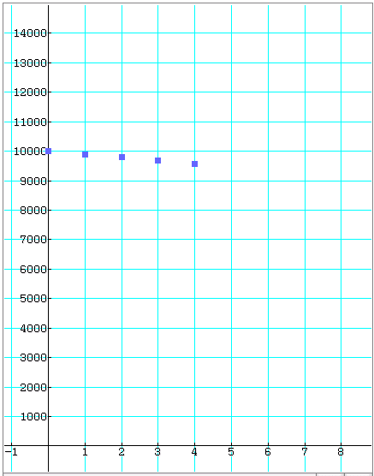 4. 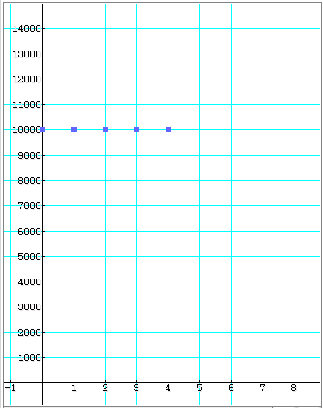

|  |  |  |  |  |
| --- | --- | --- | --- | --- |
| Graph | 1 | 2 | 3 | 4 |
| Recursive Rule |  |  |  |  |

**Question Five: [2, 3, 3, 2: 10 marks]**

Jon Snow obtains a personal loan of $3 500 to buy a laptop. He is required to make $390 repayments at the end of each month. The table below shows the amount owing on the loan at the start of each month, the interest payable for that month, the repayment and the amount owing at the end of the month for the first few months of the loan.

|  |  |  |  |  |
| --- | --- | --- | --- | --- |
| **Month** | **Amount owing at the start of the month ($)** | **Interest ($)** | **Repayment ($)** | **Amount owing at the end of the month ($)** |
| 1 | 3500 | 34.71 | 390 | 3144.71 |
| 2 | 3144.71 | 31.19 | 390 | 2785.89 |
| 3 | 2785.89 | 27.63 | 390 | 2423.52 |
| 4 | 2423.52 | 24.033 | 390 | 2057.55 |
| 5 | 2057.55 | 20.40 | 390 | 1687.96 |

a) Calculate the annual interest rate.

b) In which month would Jon Snow pay off the loan and how much is his final repayment.

c) State the recursive rule to show the amount owing at the start of each month.

d) What is the total amount of money Jon Snow pays for his laptop.

**Topic: Recurrence Relation and Compound Interest SOLUTIONS**

Time: 45 mins Marks: /45 marks

**Calculator Assumed**



**Question One: [3, 8: 11 marks]**

a) Compare the amount of interest earned in one year on a $20 000 investment which is earning 8.8% interest p.a if interest is compounding:

i) annually

 Interest = $1760

ii) monthly

 Interest = $1832.75

 iii) daily

Interest = $1839.53

b) Write the recursive rule to determine the value of the investment at the end of each year for each of the different compounding periods mentioned in part a).

i) $T_{n+1}=T_{n}×1.088 T_{0}=20 000$

ii) $T_{n+1}=T_{n}×{\left(1+\frac{0.088}{12}\right)}^{12} T_{0}=20 000$

iii) $T_{n+1}=T_{n}×{\left(1+\frac{0.088}{365}\right)}^{365} T_{0}=20 000$

**Question Two: [2, 4, 3, 2, 2: 13 marks]**

Kerry is saving a deposit to buy a house. She has some money which she invests in an account paying 9.0% interest p.a compounding monthly. She adds $500 to this account at the end of each month.

|  |  |  |  |  |
| --- | --- | --- | --- | --- |
| Month  (n) | Balance at the start of the month ($)  (Tn) | Interest ($) | Installment ($) | Balance at the end of the month ($) |
| 1 | A | 37.5 | 500 | B |
|  |  |  |  |  |
| 3 | 6079.03 | 45.59 | 500 | 6624.62 |
| 4 | C | D | 500 | E |

Kerry was trying to calculate her future savings but she spilled coffee on the table and some of the information became smudged.

a) Calculate A, the value of the initial investment.

b) Calculate the value of B, C D and E.



c) Write the recursive rule to describe the amount of money in the account at the start of each month.



d) What is the balance in the account at the end of the first year?

e) If Kerry wants to have a $20 000 deposit in 18 months’ time, how much do her monthly installments need to be?

**Question Three: [8 marks]**

Consider the following investment accounts for a $10 000 investment over 10 years.

A: 7.2% interest p.a compounding annually for the first 3 years and then monthly at a rate of 6% p.a there after.

B: 5.0% interest p.a compounding monthly.

C: 4.5% interest p.a compounding daily.

Which account offers the highest return?



**Question Four: [3 marks]**

The following graphs relate to the recursive rules below. Match each graph to the relevant recursive rule.

1.  2. 

3.  4. 

|  |  |  |  |  |
| --- | --- | --- | --- | --- |
| Graph | 1 | 2 | 3 | 4 |
| Recursive Rule | D | A | B | C |

**Question Five: [2, 3, 3, 2: 10 marks]**

Jon Snow obtains a personal loan of $3 500 to buy a laptop. He is required to make $390 repayments at the end of each month. The table below shows the amount owing on the loan at the start of each month, the interest payable for that month, the repayment and the amount owing at the end of the month for the first few months of the loan.

|  |  |  |  |  |
| --- | --- | --- | --- | --- |
| **Month** | **Amount owing at the start of the month ($)** | **Interest ($)** | **Repayment ($)** | **Amount owing at the end of the month ($)** |
| 1 | 3500 | 34.71 | 390 | 3144.71 |
| 2 | 3144.71 | 31.19 | 390 | 2785.89 |
| 3 | 2785.89 | 27.63 | 390 | 2423.52 |
| 4 | 2423.52 | 24.033 | 390 | 2057.55 |
| 5 | 2057.55 | 20.40 | 390 | 1687.96 |

a) Calculate the annual interest rate.



$11.9\% p.a$

b) In which month would Jon Snow pay off the loan and how much is his final repayment.

Pays it off in 10 months. Final repayment is $390-215.73=\$174.27$

c) State the recursive rule to show the amount owing at the start of each month.



$$T_{n+1}=T_{n}×1.00992-390 T_{1}=3500$$

d) What is the total amount of money Jon Snow pays for his laptop.

